Create two machine of ubunto

Yes, the idea is correct, 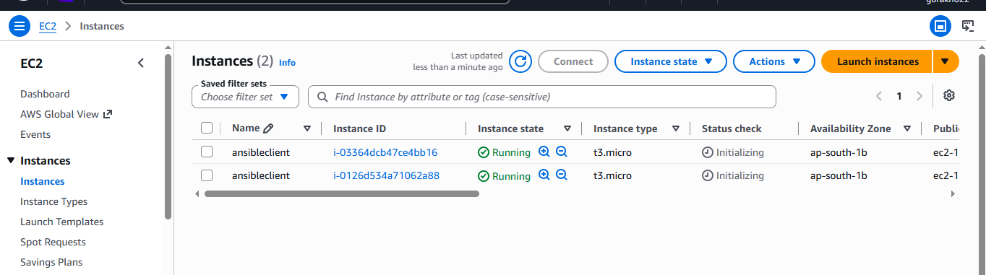but there are two path/command corrections.
1. Edit SSH configuration
Use:
sudo vi /etc/ssh/sshd_config
Not /etc/sh/sshd_config.
Find:
#PasswordAuthentication yes
#PubkeyAuthentication yes
Remove #:
PasswordAuthentication yes
PubkeyAuthentication yes
On Ubuntu, PubkeyAuthentication yes is normally already enabled by default, so you may not need to change it.
2. Check the sshd_config.d directory
cd /etc/ssh/sshd_config.d
ls
You may see a file such as:
60-cloudimg-settings.conf
Check it:
sudo cat 60-cloudimg-settings.conf
If it contains:
PasswordAuthentication yes
that's okay.
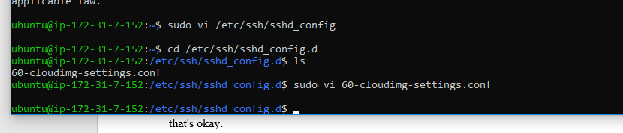
3. Validate before restarting
Very important: check the SSH configuration first:
sudo sshd -t
If there is no output, the configuration is valid.
4. Restart SSH
On Ubuntu:
sudo systemctl restart ssh
Check:
sudo systemctl status ssh
You want:
Active: active (running)

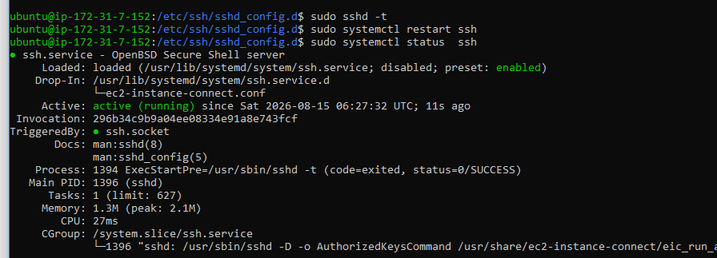

5. For your Ansible project
You ultimately want:
CentOS 9
Ansible Control Node
|
| SSH
├──────────→ Ubuntu ansible-client-1
|
└──────────→ Ubuntu ansible-client-2

1. Create ansible user on Red Hat/CentOS 9 Control Node
On the Red Hat/CentOS machine:
sudo useradd ansible
sudo passwd ansible
Verify:
id ansible
You should see something like:
uid=1001(ansible) gid=1001(ansible) groups=1001(ansible)

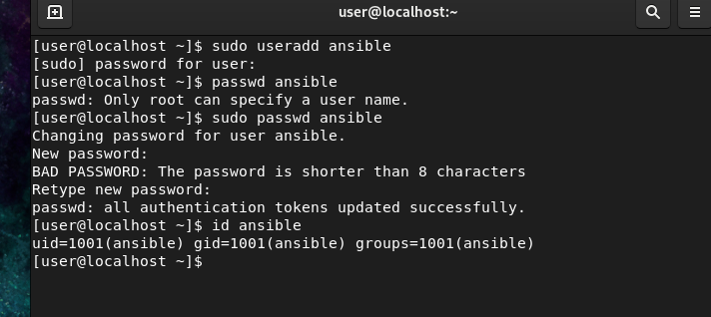

2. Create the same user on Ubuntu Client 1
SSH into Ubuntu Client 1:
ssh -i your-key.pem ubuntu@CLIENT1-PUBLIC-IP
Then:
sudo useradd ansible
sudo passwd ansible
Verify:
id ansible

3. Create the same user on Ubuntu Client 2
Connect:
ssh -i your-key.pem ubuntu@CLIENT2-PUBLIC-IP
Then:
sudo useradd ansible
sudo passwd ansible
Verify:
id ansible
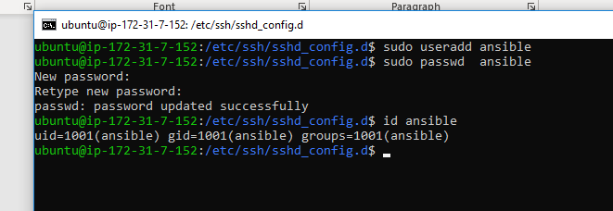

sudo mkdir -p /home/ansible
sudo chown ansible:ansible /home/ansible
sudo chmod 700 /home/ansible
sudo usermod -s /bin/bash ansible

4. Add them to /etc/hosts on Red Hat/CentOS
On your Red Hat/CentOS Control Node:
sudo vi /etc/hosts
Add:
10.0.1.20 ansible-client-1
10.0.1.21 ansible-client-2

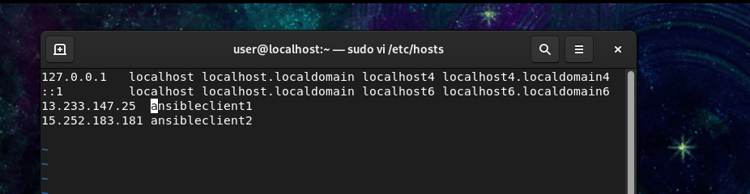
You can also use FQDN-style names:
10.0.1.20 ansible-client-1
10.0.1.21 ansible-client-2
Save and exit.

5. Test hostname resolution
From Red Hat/CentOS:
ping -c 2 ansible-client-1
and:
ping -c 2 ansible-client-2

passwordless ssh

1. On CentOS 9 — switch to ansible user
su - ansible
Check:
whoami
Should show:
ansible
2. Generate passwordless SSH key
Run:
ssh-keygen -t rsa -b 4096

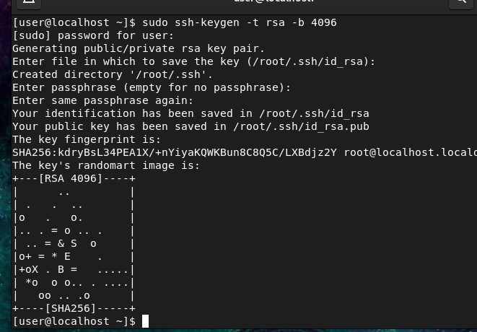
When asked:
Enter file in which to save the key:
Just press Enter.
Then:
Enter passphrase:
Press Enter.
Again:
Enter same passphrase again:
Press Enter.
This creates:
~/.ssh/id_rsa
~/.ssh/id_rsa.pub
Check:
ls -l ~/.ssh
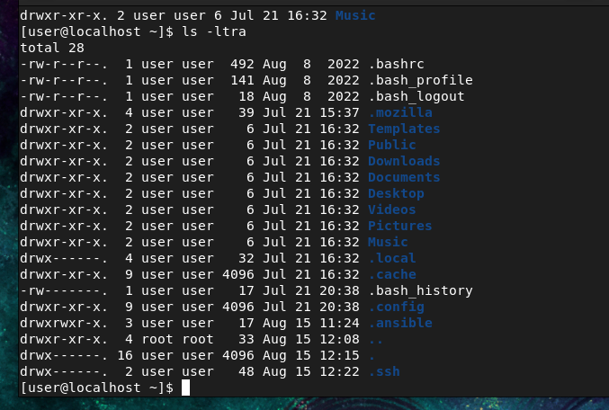
You should see:
id_rsa
id_rsa.pub
Never share id_rsa. The file you copy to the Ubuntu machines is id_rsa.pub.

3. Copy key to Ubuntu Client 1
Because you created the ansible user on Ubuntu:
ssh-copy-id ansible@ansibleclient1
It will ask for the ansible user's password on Client 1.
Enter it.
You should get:
Number of key(s) added: 1
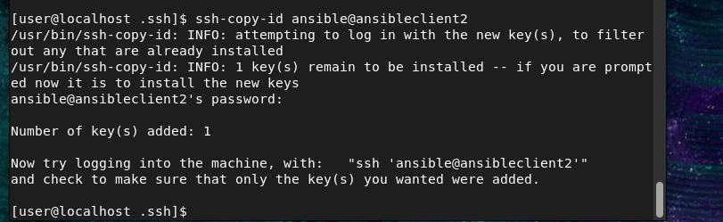

4. Copy key to Ubuntu Client 2
ssh-copy-id ansible@ansible-client-2
Enter the ansible user's password.

5. Test passwordless SSH
Client 1:
ssh ansible@ansibleclient1
Client 2:
ssh ansible@ansible-client-2
If configured correctly, you should not be asked for the ansible password.
Exit:
exit

